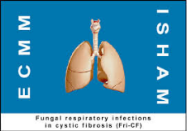

**4th Meeting of the ISHAM Working group**

**Fungal respiratory infections in Cystic Fibrosis**

**Osuna (Seville), Spain, June 5th – 6th, 2017**

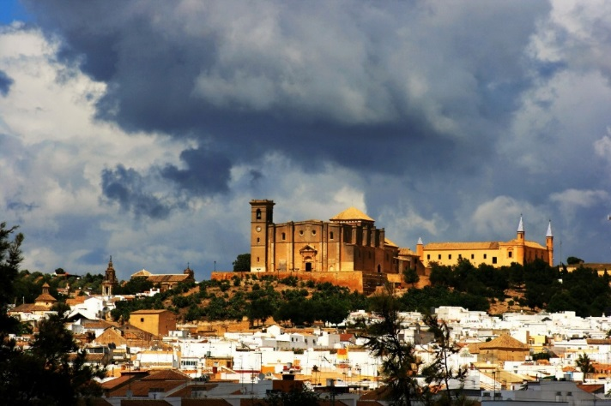

**REGISTRATION FORM (Deadline 5th May 2017)**

**Family name:**

**First (given) name:**

**Title:**

**Job title**

**Company / Institute:**

**Department:**

**Address**

**Postal code: Country:**

**Telephone:**

**E-mail address:**

**Accompanying person*  Yes  No**

**\*** For organizing purposes please let us know if you have an accompanying person not registered to the meeting that would like to attend social events.

Send the form to [fundacion@micellium.org](mailto:fundacion@micellium.org)